Lab: Syntax, Functions and Statements
Problems for in-class lab for the "JavaScript Advanced" course @ SoftUni. Submit your solutions in the SoftUni judge system at https://judge.softuni.bg/Contests/1795/Lab-Syntax-Functions-and-Statements.

String Length
Write a JS function that takes three string arguments as an input.

Calculate the sum of the length of the strings and the average length of the strings rounded down to the nearest integer.
The input comes as three string arguments passed to your function.
The output should be printed on the console on two lines.

Examples
Input | Output
'chocolate', 'ice cream', 'cake' | 22  7

Input | Output
'pasta', '5', '22.3' | 10  3

Hints
- Write a function that receives three string arguments.
- Declare two variables named sumLength and averageLength that will keep the mathematical results.
- Calculate the length of the strings using the length property.

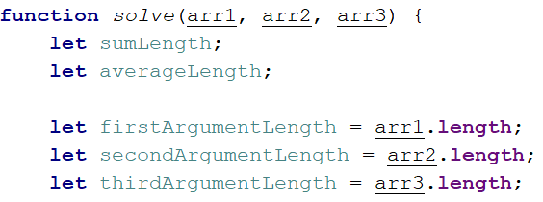
- Calculate the sum of the three lengths.
- Calculate the average length of the strings rounded down to the nearest integer. Use the Math.floor() function.
- Print the results on the console.
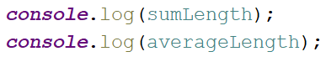

Math Operations
Write a JS function that takes two numbers and a string as an input.

The string may be one of the following: '+', '-', '*', '/', '%', '**'.

Print on the console the result of the mathematical operation between both numbers and the operator you receive as a string.
The input comes as two numbers and a string argument passed to your function.
The output should be printed on the console.

Examples
Input | Output |  | Input | Output
5, 6, '+' | 11 |  | 3, 5.5, '*' | 16.5

Hints
- Write a function which receives three arguments:
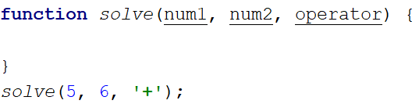
- Declare a variable named result that will keep your mathematical result.
- Write down switch command that will take the string from your input and depending on it, perform the mathematical logic between the two numbers.

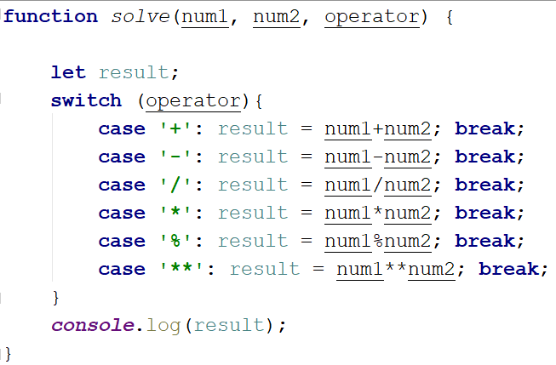
- Print the result on the console.
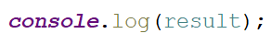

Sum of Numbers N…M
Write a JS function that takes two numbers n and m as an input and prints the sum of all numbers from n to m.
The input comes as two string elements that need to be parsed as numbers.
The output should return the sum.

Examples
Input | Output
'1', '5' | 15

Input | Output
'-8', 20' | 174

Hints
- Write a function that receives two string arguments and parse them as numbers. Use Number(string) function or just put the '+' sign before the string.
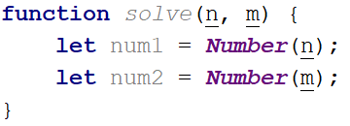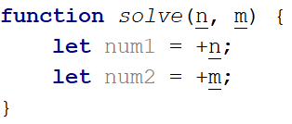
- Declare a variable named result that will keep the mathematical results.
- Write a for loop from num1 to num2 and for every turn of the cycle, until it’s completed, add the current value.
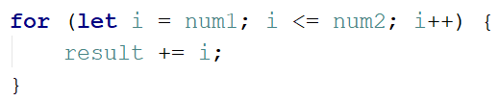
- Finally, return the result.
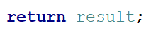

Largest Number
Write a function that takes three number arguments as an input and find the largest of them. Print the following text on the console: 'The largest number is {number}.'.
The input comes as three number arguments passed to your function.
The output should be printed to the console.

Example
Input | Output
5, -3, 16 | The largest number is 16.
Input | Output
-3, -5, -22.5 | The largest number is -3.

Hints
- Write a function that receives three number arguments.
- Declare a variable named result that will keep the result.
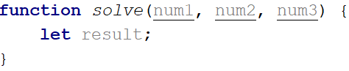
- Make several checks to find out the largest of the three numbers. Start with num1.
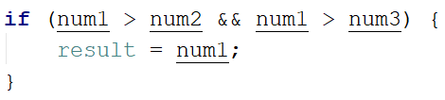
- Do the same for the others.
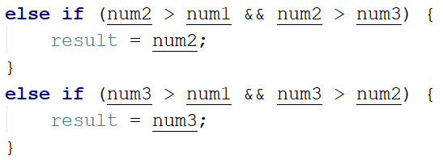
- Print the result on the console.

Circle Area
Write a function that takes a single argument as an input.
Check the type of the input argument. If it is a number, assume it is the radius of a circle and calculate the circle area. Print the area rounded to two decimal places.
If the argument type is NOT a number, print the following text on the console:
'We can not calculate the circle area, because we receive a {type of argument}.'
The input comes as a single argument passed to your function.
The output should be printed on the console.

Example
Input | Output |  | Input | Output
5 | 78.54 |  | 'name' | We can not calculate the circle area, because we receive a string.

Hints
- Write a function that receives a single argument.
- Declare a variable named result that will keep your result.
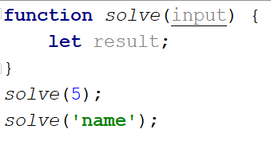

- Check the type of the input argument with the typeof operator.
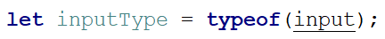
- If the type is equal to 'number', calculate the circle area and print it on the console rounded to two decimal places. To do this, use the method toFixed().
The Math.pow() function returns the base to the exponent power, that is, base exponent. You can find more information about the area here:
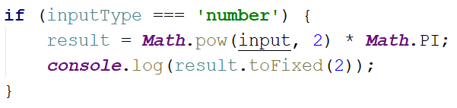
- If the type is NOT a 'number', print the following text on the console:
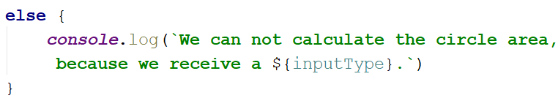

Square of Stars
Write a function that prints a rectangle made of stars with variable size, depending on an input parameter. If there is no parameter specified, the rectangle should always be of size 5. Look at the examples to get an idea.
The input comes as a single number argument.
The output is a series of lines printed on the console, forming a rectangle of variable size.

Examples
Input | Output |  | Input | Output |  | Input | Output |  | Input | Output
1 | * |  | 2 | * *  * * |  | 5 | * * * * *  * * * * *  * * * * *  * * * * *  * * * * * |  |  | * * * * *  * * * * *  * * * * *  * * * * *  * * * * *

Day of Week
Write a function that prints a number between 1 and 7 when a day of the week is passed to it as a string and an error message if the string is not recognized.
The input comes as a single string argument.
The output should be returned as a result.

Examples
Input | Output |  | Input | Output |  | Input | Output
Monday | 1 |  | Friday | 5 |  | Invalid | error

Aggregate Elements
Write a program that performs different operations on an array of elements. Implement the following operations:
- Sum(a_{i}) - calculates the sum all elements from the input array
- Sum(1/a_{i}) - calculates the sum of the inverse values (1/a_{i}) of all elements from the array
- Concat(a_{i}) - concatenates the string representations of all elements from the array
The input comes as an array of number elements.
The output should be printed on the console on a new line for each of the operations.

Examples
Input | Output |  | Input | Output
[1, 2, 3] | 6  1.8333  123 |  | [2, 4, 8, 16] | 30  0.9375  24816

*Words Uppercase
Write a program that extracts all words from a passed in string and converts them to upper case. The extracted words in upper case must be printed on a single line separated by ", ".
The input comes as a single string argument - the text to extract and convert words from.
The output should be a single line containing the converted string.

Examples
Input | Output |  | Input | Output
'Hi, how are you?' | HI, HOW, ARE, YOU |  | 'hello' | HELLO

Hints
- You may need to use a Regular Expression or alternatively check for all delimiters that can be found in a sentence (ex. ",", " ", "!", "?" and so on).

